2nd ANNUAL
BOB CAMPBELL CLASSIC
TOURNAMENT
December 10-12, 2021
SPONSORSHIP PACKAGE
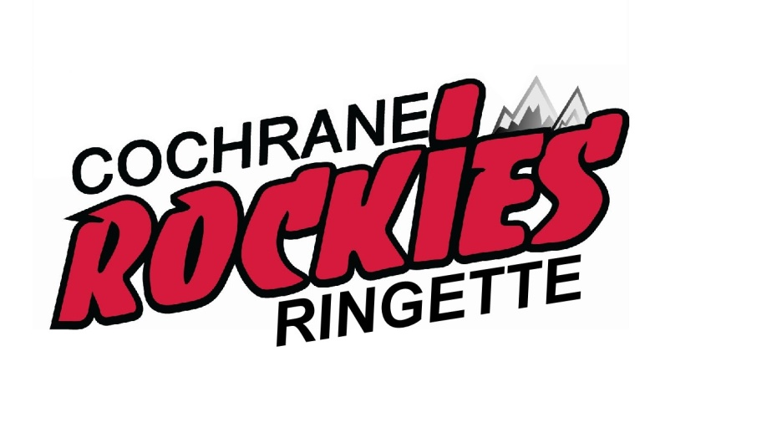
Fast, Fun & Furious
Sponsorship Contacts
Crystal Nagy 403-988-2927

Website: cochraneringettetourney.com
Email: tournamentdirector@cochraneringette.com

Why support our Ringette Tournament?
- There are over 150 local families involved in Cochrane Ringette. These families live and shop in Cochrane. They are loyal to the businesses that support their children and their activities.
- In the past, the Tournament has brought over 700 athletes to Cochrane and approximately $200,000 was injected into our local economy and we have similar expectations this year. Hotels alone had just under $35,000 in revenue in one weekend!
Tournament Details:
- Approximately 600 Athletes (ages 4-18 years old)
- 33 Visiting Teams
- 70 Games
- Approximately 2,000 fans
- Main arena played at is Spray Lake Sawmills Family Sports Centre
Tournament Goals:
- To provide a first class tournament that will attract teams from across Alberta
- Promote and support local businesses
- Raise awareness of the sport of Ringette
- Raise funds to improve the Ringette program
  - Technical sessions / player development
  - Goalie Clinics
  - Coaching Development
  - Reduction of fees

We have designed this tournament to benefit the local economy. Our approach is to promote local first. We plan to market Cochrane as a town that has all the services available for visitors to stay, eat, shop and play. In exchange, we hope that you will support our Tournament.

***Tournament Website***
www.cochraneringettetourney.com
Logos of all our sponsors will be displayed on our tournament website along with schedules, participating team rosters, the tournament program and updated scores and standings. Company coupons / discounts can also be advertised on our website with sponsorship.
***Tournament T-Shirts***
Due to the popularity and success of our Tournament T-Shirts, we will again be issuing over 600 T-Shirts to all participating players with sponsoring company logos on the back. This opportunity is available to all Medal, Gold, Silver & Bronze sponsors. Deadline is November 1 to be listed on t-shirts.
How can you support our Tournament?
- Gold, Silver or Bronze Sponsor
- Sponsor Medals
- Sponsor Dressing Room Signs
- Coupon Wall
- Donate a Silent Auction Item
- Donate a Raffle Item
- Donate “Thank you” Packages or “Swag Bag” Items
- COME CHEER ON OUR TEAMS!

2021 BOB CAMPBELL CLASSIC TOURNAMENT
SPONSORSHIP AGREEMENT FORM
(Tournament Copy)
COMPANY NAME:
CONTACT NAME:
ADDRESS:
PHONE:
EMAIL:
Would you like to be contact by email next year? Yes/No
Select Sponsorship Package (Check One)
Heart & Hustle Sponsor
Medal Sponsor $1,500
Gold Level Sponsor $1,000
Silver Level Sponsor $750
Bronze Level Sponsor $500
$300 – Dressing Room Door Signs, 1 Lobby Sign
Coupon Wall - Provide a coupon for your business and it will be emailed or distributed to teams prior to the tournament and available on the ‘Coupon Wall’ during the tournament.
Raffle Items (donated merchandise or gift cards)
Value of item(s):
Description:

For payment or item donations, please contact:
Crystal Nagy 403-988-2927

E-transfer is preferable (treasurer@cochraneringette.com) but cheques made to Cochrane Classic Ringette Tournament can also be picked up or mailed to: Cochrane Classic Ringette Tournament, PO Box 34 Cochrane, AB T4C 1A4

2021 BOB CAMPBELL CLASSIC TOURNAMENT
SPONSORSHIP AGREEMENT FORM
(Sponsor Copy)
COMPANY NAME:
CONTACT NAME:
ADDRESS:
PHONE:
EMAIL:
Would you like to be contact by email next year? Yes/No
Select Sponsorship Package (Check One)
Heart & Hustle Sponsor
Medal Sponsor $1,500
Gold Level Sponsor $1,000
Silver Level Sponsor $750
Bronze Level Sponsor $500
$300 – Dressing Room Door Signs, 1 Lobby Sign
Coupon Wall - Provide a coupon for your business and it will be emailed or distributed to teams prior to the tournament and available on the ‘Coupon Wall’ during the tournament.
Raffle Items (donated merchandise or gift cards)
Value of item(s):
Description:

For payment or item donations, please contact:
Crystal Nagy 403-988-2927

E-transfer is preferable (treasurer@cochraneringette.com) but cheques made to Cochrane Classic Ringette Tournament can also be picked up or mailed to: Cochrane Classic Ringette Tournament, PO Box 34 Cochrane, AB T4C 1A4

Sponsorship Levels
All sponsors of $500 and above will receive the following:
- Company Logo on Association & Tournament Website for 1 year
- Acknowledgement in local paper
- Company Logo Included in Correspondence to Coaches
- Company Banner Displayed (must provide own banner)
- Dressing Room Door Signs
- Email to Cochrane ringette association families reminding them of our wonderful sponsors (twice in the year)

All Sponsors of $500 and above – please email vector file of
company logo to tournamentdirector@cochraneringette.com
Heart & Hustle Sponsor - $TBA
- This sponsorship has flexibility based on the heart & hustle award chosen
- Logo on Back of T-Shirt (deadline November 1)
- Signs Posted Throughout Arena During Tournament
Medal Sponsor - $1,500
- Acknowledgment at Gold Medal Games
- Large Logo on Back of T-Shirt (deadline November 1)
- Large Signs Posted Throughout Arena During Tournament
Gold Sponsor - $1,000
- Large Logo on Back of T-Shirt Deadline November 1)
- Large Signs Posted Throughout Arena During Tournament

Silver Sponsor - $750
- Medium Logo on Back of T-Shirt (deadline November 1)
- Medium Signs Posted Throughout Arena During Tournament
Bronze Sponsor - $500
- Small Logo on Back of T-Shirt (deadline November 1)
- Small Signs Posted Throughout Arena During Tournament
INTERESTED IN ANNUAL SPONSORSHIPS OR TEAM SPONSORSHIPS?? WE WANT TO GET YOUR IDEAS ON HOW TO BEST SUIT YOUR NEEDS!
PLEASE CONTACT OUR FUNDRAISING COORDINATOR
fundraisingcoordinator@cochraneringette.com

